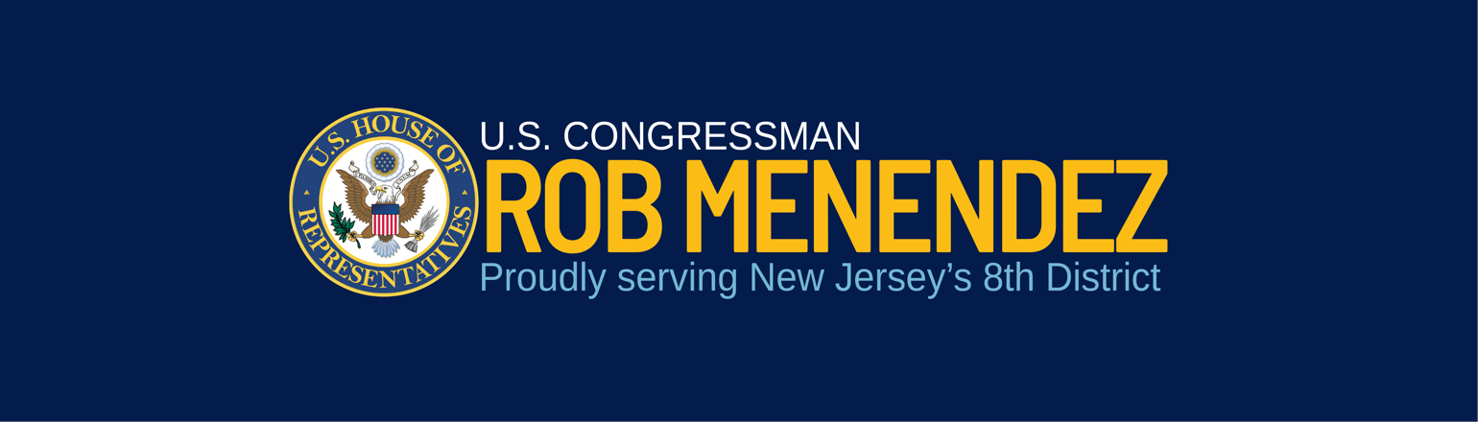
Fiscal Year 2025 Community Project Funding Requests

The House Appropriations Committee (Committee) is soliciting Community Project Funding (CPF) requests from Members of Congress for Fiscal Year 2025 (FY25). CPFs provide an opportunity to fund projects that can support our communities and improve lives in New Jersey’s 8th Congressional District. If you are interested in submitting an application for funding, please be sure to thoroughly read general guidance and Subcommittee eligibility information, linked below, on the Committee’s website before filling out the below form.

Per the rules enforced by the Committee, each Member of Congress can only submit 15 CPF requests across appropriate Subcommittees for consideration. The Committee decides which of a Member’s submissions will receive funding.

All NJ-08 applications must be submitted by email to NJ08.Appropriations@mail.house.gov by COB on Tuesday, April 30, 2024 with the subject line “[Subcommittee]-[Title of Project].” Due to the Committee’s abbreviated deadlines, the Office will not be able to consider applications submitted after this date.

Applications must include the below form and evidence of community support via attachments.

In addition to account-specific eligibility requirements, all applications and projects must meet the following criteria established by the Committee:

- The recipient of the CPF must be a state or local entity or a 501(c)(3) nonprofit organization. The Economic Development Initiative (EDI) Account is only open to state or local entities; nonprofits may not apply under the EDI account under the FY25 guidance. For-profit entities are not eligible to apply for CPF funding.

- All funding must be for FY25 only. Multi-year funding is not applicable.

- Applicants must provide evidence of community support. Letters of support from elected officials or local or state agencies, local or state legislation expressing support, articles in the press, and certain state plans or community development plans could all satisfy this requirement.

- Projects must be authorized in federal law, and applicants must cite the appropriate federal nexus. Please read account-specific guidance to determine whether your project meets this criteria.

- CPF requests must meet applicable eligibility requirements for the Subcommittee and program in which the request is made, including applicable underlying statutory and regulatory requirements such as cost shares. Please thoroughly read Subcommittee guidance before applying:
  - Agriculture, Rural Development, Food and Drug Administration, and Related Agencies
    - Natural Resources Conservation Service (Conservation Operations)
    - Agricultural Research Service (Buildings and Facilities)
    - Rural Housing Service (Community Facilities)
    - Rural Utilities Service (ReConnect Program)
    - Rural Utilities Service (Distance Learning and Telemedicine Grants)
    - Rural Utilities Service (Rural Water and Waste Disposal Grants)
  - Commerce, Justice, Science, and Related Agencies
    - NIST—Scientific and Technical Research
    - NOAA—Coastal Zone Management
    - COPS Technology and Equipment
    - Byrne Justice
    - NASA Safety, Security, and Mission Services
  - Energy and Water Development
    - Army Corps of Engineers Investigations
    - Army Corps of Engineers Construction
    - Army Corps of Engineers Mississippi River and Tributaries
    - Army Corps of Engineers Operation and Maintenance
    - Interior/Bureau of Reclamation Water and Related Resources
  - Homeland Security
    - Federal Emergency Ops. Centers
    - FEMA Pre-Disaster Mitigation
  - Interior, Environment, and Related Agencies
    - STAG—Clean Water State Revolving Fund
    - STAG—Drinking Water State Revolving Fund
  - Military Construction, Veterans Affairs, and Related Agencies
    - Army
    - Army National Guard
    - Army Reserve
    - Navy & Marine Corps
    - Navy Reserve
    - Air Force and Space Force
    - Air National Guard
    - Air Force Reserve
    - DoD, Defense-Wide
  - Transportation, and Housing and Urban Development, and Related Agencies
    - CDBG – Economic Development Initiatives
    - Airport Improvement Program
    - Highway Infrastructure Projects
    - Transit Infrastructure Projects
    - Consolidated Rail Infrastructure and Safety Improvements
    - Port Infrastructure Development Program

- Please note the Republican Majority has eliminated eligibility for the following accounts: Defense, Labor Health and Human Services/Education, and Financial Services.

- Funding may not be requested for memorials, museums, or other commemorative projects.

Please complete the questions as thoroughly as possible for an increased chance of consideration. Note that leaving questions blank may result in decreased consideration and success of your request. Additionally, our office may be unable to consider your application if it is missing any relevant information.

Applicant Information
- Name of point of contact
- Phone and email address of point of contact
- Legal name of recipient entity
- Address of recipient entity
- Type of entity (local government, 501(c)(3)):
  - If the recipient is a 501(c)(3), please provide a description of the organization and the link to its official website.

Project Information
- Name of project
- Postal address of project location (must be in NJ-08)
- Brief purpose of project
- Detailed project description
- Total cost of project
- Detailed breakdown on proposed use of federal funds (construction, salaries, etc.)
- Is this a new or ongoing project, and what is the project timeline for completion of the project?

Account Information
- Under which Subcommittee, department, and account are you applying for funding?
- Have you reviewed all eligibility information from our office guide and the Committee’s website for that account?
- Where is the project authorized in federal law? Please provide the statutory authorization.
- Does this account include a statutory cost-share requirement? If so, please provide the funding source for the required non-federal share.
- How would this project benefit the public, and how is it a good use of taxpayer funds?
- Has this project received federal funding in the past?
- Is this project included in any relevant state action plan?
- Are you submitting this request to any other Members of Congress?
- Please review account-specific application requirements and provide all additional information required for your Subcommittee here. The office will not be able to consider applications that do not include this information.

Please be aware that Members of Congress are required to post all submitted CPF requests to their websites. The posting must include the name of the proposed recipient, address, the amount of the request, and an explanation of the purpose and justification for the use of taxpayer funds.
Staff Contact List: For specific questions about the process or your request, please reach out to my staff directly:
- Alexandria Musser, Legislative Director – alexandria.musser@mail.house.gov
- Jeremy Julis, District Director – jeremy.julis@mail.house.gov

